### **Project 4：Controlling LED By Button Module**

**Description：**

In this project, we will control LED to light on and off via button module. When the button is pressed, the signal end outputs low level (0); when released, the signal end of sensor keeps high level(1).

**Equipment:**

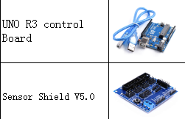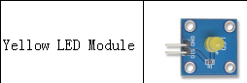

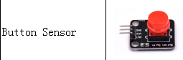

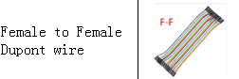

Connection:

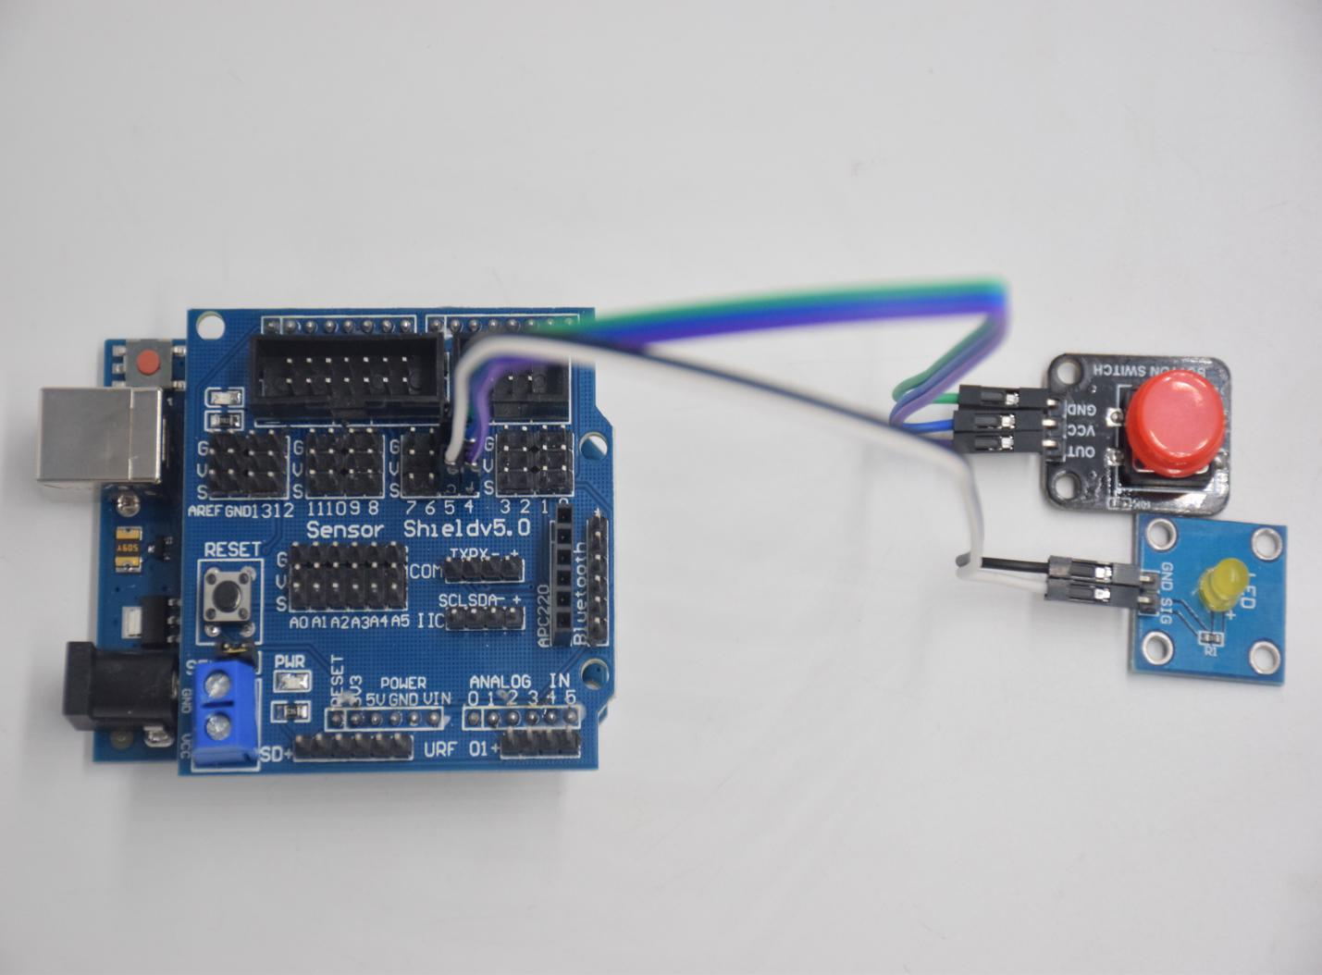

key module：

GND -- GND

VCC -- 5V

OUT -- D4

LED:

GND -- GND

SIG -- D5

**Test Code：**

Next to design the program, we make LED on by button. Comparing with previous experiments, we add a conditional judgement statement. We use if statement. The written sentences of Arduino is based on C language, therefore, the condition judgement statement of C is suitable for Arduino, like while, swich, etc.  
For this lesson, we take simple “if” statement as example to demonstrate:

If button is pressed, digital 4 is low level, then we make digital 5 output high level , then LED will be on; conversely, if the button is released, digital 4 is high level, we make digital 5 output low level, then LED will go off.  
As for your reference：

int ledpin = 5; // Define the led light in D5

int inpin = 4; // Define the button in D4

int val; // Define variable val

void setup ()

{

pinMode (ledpin, OUTPUT); // The LED light interface is defined as output

pinMode (inpin, INPUT); // Define the button interface as input

}

void loop ()

{

val = digitalRead (inpin); // Read the digital 4 level value and assign it to val

if (val == LOW) // Whether the key is pressed, the light will be on when pressed

{digitalWrite (ledpin, HIGH);}

else

{digitalWrite (ledpin, LOW);}

}

**Test Result：**

This experiment is pretty simple, and widely applied to various of circuits and electrical appliances. In our life, you could find this principle on any device, such as the backlight is on when press any buttons, which is the typical appliance.